Parish of Saint Matthew with Saint Jude, Brixton.
Learning to live in tune with God’s good Creation
St Matthew’s Lent Challenge 2019

Psalm 24.1-2
The earth is the Lord’s and all that is in it,
the world, and those who live in it;
for he has founded it on the seas,
and established it on the rivers.
St Matthews Lent Challenge
An Environmental and Spiritual Challenge –to learn to live in a way that is in tune with God’s good creation.
There are four sections that you might like to concentrate on. Just one for the whole of Lent, or more than one.

Water
Food
Each section contains key facts actions, pledges and prayer

Plastics
Transport

A helpful pattern to use is:
READ information and let it sink in
REFLECT
on how it challenges you
& PRAY
PLAN and guided by the Spirit write down what you will do
ACT on your commitments as a concrete way of turning to
Christ and living a more Godly life.

At the end of Lent, you will be able to look back and see which new habits you have developed and which old habits have fallen away as you move forward to celebrate Jesus’ passion and resurrection renewed in your ability to live gently in God’s world

Help us to change our ways of living
To be in tune with your creation
That, as we are revealed as your children,
All creation may be restored to glory. Amen

Page 1
“The earth is the Lord’s and all that is in it,
the world and those who live in it; for he has founded it on the sea and established it on the rivers.” Psalm 24: 1-2.

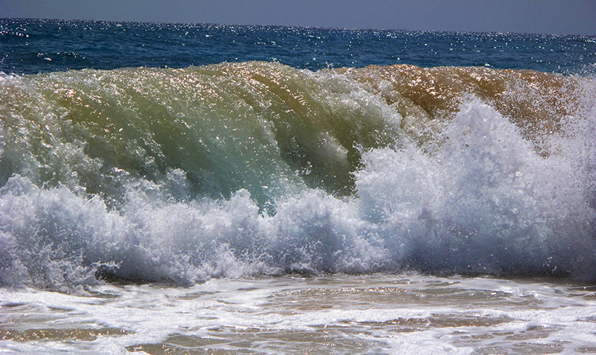

WATER

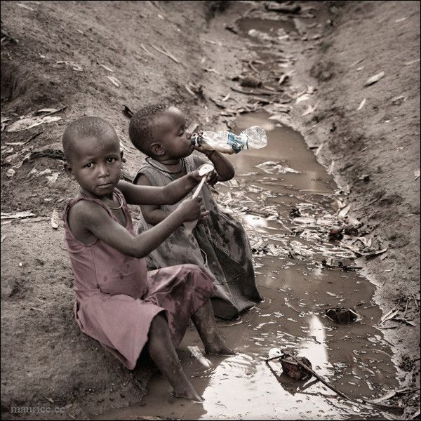

“We know that the whole creation has been groaning in labour pains until now; for it awaits with eager longing for the revelation of the children of God.” Romans 8: 22 & 19.
Page 2
Key Facts.

- Water is essential to life – we can’t live without it!
- It was there right at the beginning of God’s creation – even before light! (Genesis 1)
- The human body is 60% water.
- Around 70% of the world is covered in water – mainly oceans.
- Only 2.5% of the world’s water is fresh – which means drinkable.
- A massive 80% of drinkable water is locked up in Antarctic ice.
- Only 1% of drinkable water is easily available!
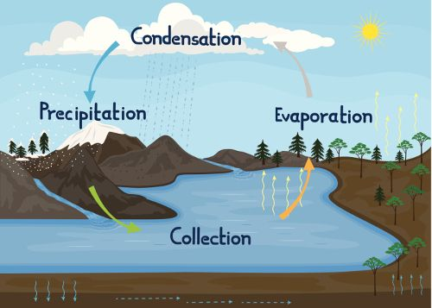

- The Water Cycle is the earth’s way of recycling its water again, and again, and again…… so it never runs out.
- When we use water, we take it out of the water cycle and must make sure to put it back in.
- When we use water, we make it dirty – think toothpaste, dirty dishes, chemicals, wee and more – and must make sure to clean it before we put it back.

Page 3
How can we look after the world’s water?
By making sure to only use what we need, and never to make it any dirtier (more polluted) than we have to!

Why should we use less water?
Because the more we use the less there is for rest of the world! But also, all the water we use must be moved and cleaned, and energy is needed to move and clean water; the more water we use the more energy we need. Even more energy is needed to heat water. Polluting energy fuels such as petrol, coal and gas are often used to move and heat water. Using less water reduces pollution and conserves energy resources. Saving water protects the world.

What else can we do?
Don’t pollute the water itself! Don’t pee in it (except in a toilet)! Don’t put anything down the drain you shouldn’t (remember the ‘Fatburg’)! Don’t put anything down the toilet you shouldn’t (no-one wants baby wipes on the beach)! Don’t throw litter (it ends up in the sea)! Just take good care of the world that God made.

Page 4
10 easy actions for Lent (and the rest of your life).

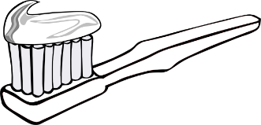
1.Turn off the tap while brushing your teeth
you’ll save 24 litres of water a day! If the whole country does it, we’ll save enough water for 500,000 homes!

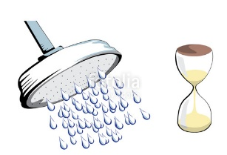
2.Take shorter showers
try the 4-minute challenge by using a shower timer – free
from Thames Water. You’ll save 15 litres a minute with a
power shower!
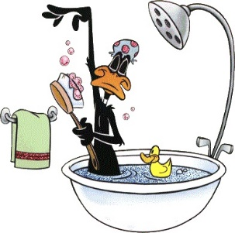
3.Shower!
A bath takes around 80 litres of water, whilst a short shower
can use only 27 litres. But take care – a long power shower
could use more water than a bath!

4.Have a smaller bath!
a 2.5cm shallower bath could save 5 litres of water.

5.Share bathwater with your family – just top-up the hot!
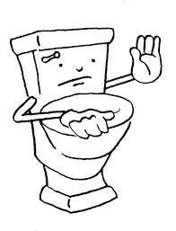
6.Only flush the toilet when you need to –
no need to flush every time you wee. Remember –
If it’s yellow let it mellow, if it’s brown flush it down.
(Only use this rule at home - not flushing in public toilets, or
other people’s homes, is considered rude.)
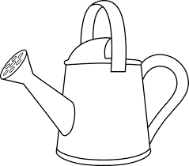
7.Recycle used household water
in the garden…..
8 ….. or for washing the car.

Page 5
9.Pick up litter
by your closest or favourite stream, river, pond, lake or
beach – and recycle or bin it.
(Remember - wear gloves, and don’t pick up anything dangerous.)

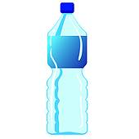
10.DON’T BUY BOTTLED WATER!
UK tap water is clean and safe and already paid for! Bottled water needs extracting and processing and transport. The plastic bottles need making and disposing of. Bottled water is costly for you and for the environment!

Page 6

My pledges for Lent:

You may like to pick one (or more) of these suggestions to practise in your home this Lent, or you might have a better idea of your own!
Write down here what you will do.

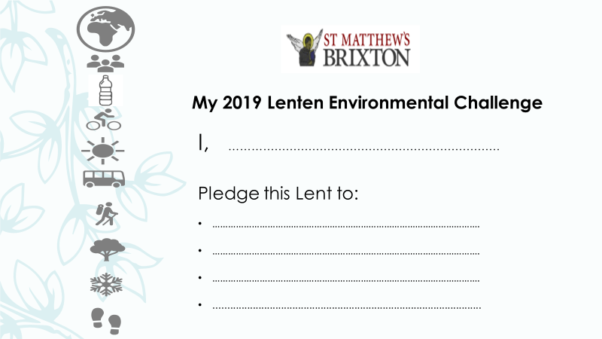

Prayer

Creator God, you have made all things good.
Help us to look after your world,
and the precious resource of water
which is essential to life.
Help us to change our ways of living
to be in tune with your creation
that, as we are revealed as your children,
all creation may be restored to glory.
Amen.

Page 7
Be fruitful and multiply, and fill the earth and subdue it; and have dominion over the fish of the sea and over the birds of the air and over every living thing that moves upon the earth. Genesis 1:28.

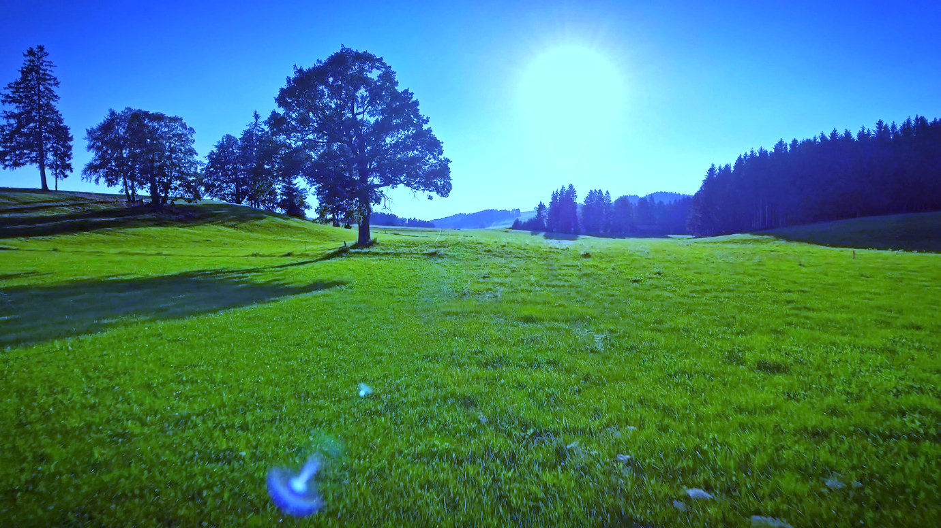

FOOD

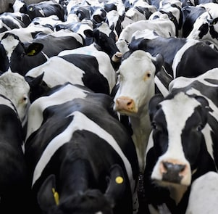
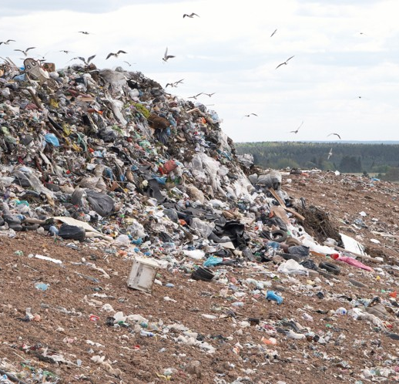

On the banks, on both sides of the river,
there will grow all kinds of trees for food.
Their fruit will be for food, and their leaves for healing.’
Ezekiel 47:12.
Page 8
Key Facts:

- Food is essential to life – we can’t live without it!
- Food is a fundamental part of God’s good creation. Genesis 1.
- Food production is one of the biggest challenges of the 21st century.
- As the human population grows, we need to produce more food – as much as 50% more food in the next 30 years.
- Food poverty is already a significant problem globally and in the UK.
- Food production is one of the biggest causes of global warming AND global warming makes food production harder – for every 1C increase in temperature, global wheat yields decrease by 6% and rice yields by 10%.

How can we look after the world’s food?
By making sure to only take what we need, and to support sustainable methods of food production.

How do my food choices make a difference?
The more food we use (and waste) the less there is for the rest of the world! Waste food is still the main component of landfill and causes carbon emissions.

Page 9
What we eat (and waste) is as important as how much.

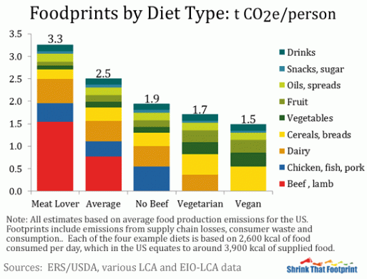

- Meat and dairy farming have the biggest impact on the environment, contributing at least 14.5% of all greenhouse gas emissions, and reducing the land and resources available to produce food crops.

- By halving grain-fed meat consumption we could feed an extra 2 billion people.

- Food produced by intensive farming has a significantly higher carbon footprint than extensive (low impact) farming. It often also uses more water, antibiotics or pesticides, has poorer animal welfare and damages local wildlife. Similarly, food that is transported long distances has a higher carbon footprint (‘food miles’) than that grown locally, and crops grown in heated polytunnels out of season are more costly to the earth than seasonal produce.

- Pasture-fed whole cuts of meat from a local farm have a significantly lower carbon footprint than intensively farmed, heavily processed, meat dishes from abroad. Vegan or vegetarian diets reliant on non-seasonal produce from the southern hemisphere are worse for the environment than those focussing on locally-sourced seasonal products.
Page 10
10 easy actions for Lent (and the rest of your life).

1.Only buy what you need.
A quarter of all food bought in the UK is wasted – that’s 10 million tonnes of food and 25 million tonnes of greenhouse gas emissions put in the bin! Aim for a ‘no-waste Lent’.

2.Be sensible about ‘best before’ dates
whilst food quality B.B.E might fall after the date, food safety will not.
Don’t mess with ‘use by’ dates though – they do refer to food safety.

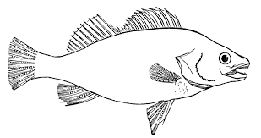
3.Use perishable (or older) foods first

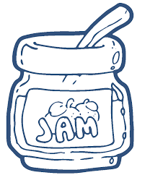
4.Freeze (or preserve) left-overs or excess
produce to eat later.

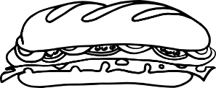
5 Make food at home to take to work or school instead of buying heavily processed and packaged foods at lunchtime.

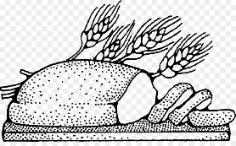
6 Eat less meat and dairy.
Consider going Vegan or Vegetarian for Lent.
Commit to only buying local meat, fish or dairy.
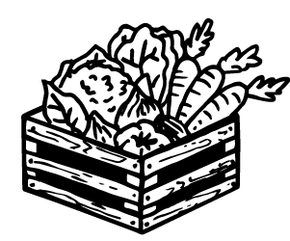
7 Only buy local, seasonal produce.
Sign up to a vegetable box scheme which favours
local produce, or produce that would otherwise go
to waste.

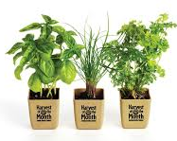
8 Grow your own fruit and veg!
From a full-blown allotment to herb pots on your
windowsill
all plants take in carbon dioxide, and you can’t get more local than home-grown.
Plant seeds for Lent! Page 11
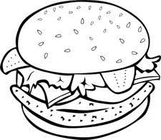
9 Avoid ready meals and takeaways, particularly if
Heavily processed or with large amounts of plastic
Or Styrofoam packaging.

10 Compost or recycle properly where waste is unavoidable.

Page 12
My pledges for Lent:

You may like to pick one (or more) of these suggestions to practise in your own home this Lent, or you might have a better idea of your own!
Write down here what you will do.

Prayer
Creator God, you have made all things good.
Help us to look after your world,
and the precious resource of food
which is essential to life.
Help us to change our ways of living
to be in tune with your creation
that, as we are revealed as your children,
all creation may be restored to glory.
Amen.

Page 13
O Lord, how manifold are your works. In wisdom you have made them all; the earth is full of your creatures. Yonder is the sea, great and wide, creeping things innumerable are there, living things both small and great. Psalm 104:24-25.

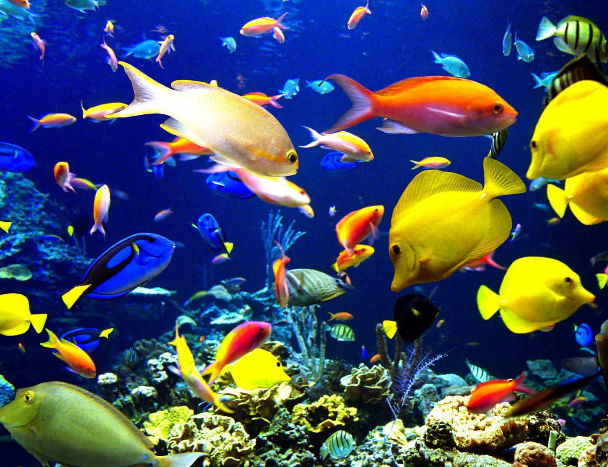

PLASTICS

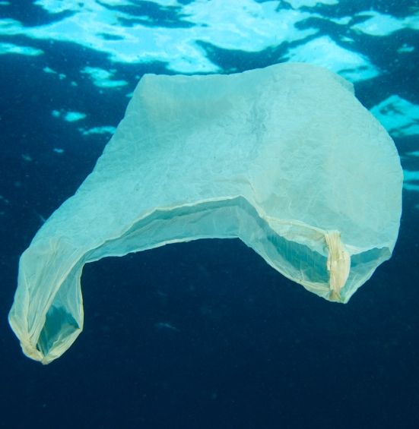
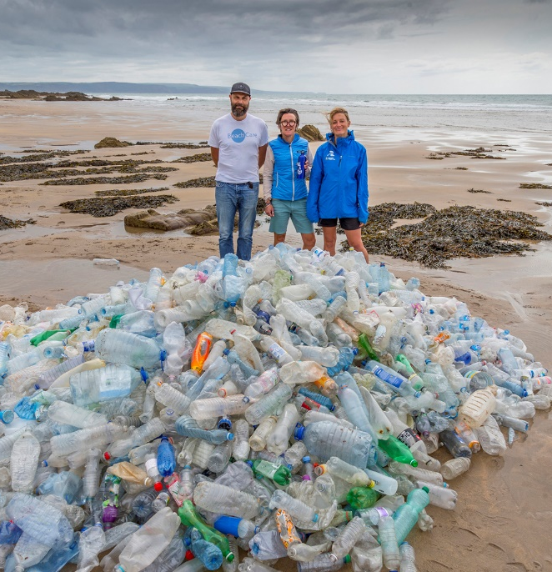

The earth dries up and withers, the world languishes and withers;
the heavens languish together with the earth.
The earth lies pollute under its inhabitants.
Isaiah 24:4-5.
Page 14
Key Facts:

- Plastic is a synthetic resource made by humans with many beneficial uses BUT……
- Over 8.3 billion tonnes of plastic have been produced since the 1950s. That’s enough plastic to cover every inch of the UK ankle-deep more than ten times over. Just 9% was recycled.
- 322million tonnes of plastic were produced in 2015 alone – that is roughly the weight of all humans alive – and that number is expected to double by 2025.
- Around half of plastic produced is single-use, and one third is for packaging.
- Drink companies produce over 500bn single-use plastic bottles annually.
- Most plastic ends up in landfill but 12.7 million tonnes end up in the oceans every year.
- At this rate, by 2050 there will be more plastic in the oceans than fish.
- Although important, recycling is not enough to stop plastic pollution. We must reduce our use of plastic in the first place. The most effective way to reduce plastic pollution is to stop using single-use plastic.
- Plastics are very durable with some taking 1000 years to decompose. Plastic drinks bottles take 450 years and plastic bags take 10-20 years.
- Decomposing plastics release toxic and carcinogenic chemicals into the land and watercourses, which can affect plants, animals and ultimately humans through our food and water.
- Every day millions of microplastics (tiny plastic beads) enter the sea from toiletry products – look for ‘polyethylene’ as an ingredient.

Page 15
- Synthetic clothing releases microplastic fibres into the water every time it is washed – natural fibres really are better.
- Plastic is made from fossil fuels (oil and gas). It is estimated that 12 million barrels of oil a year are used in making plastic bags in the US.
- Plastic production has a high carbon footprint releasing greenhouse gases into the atmosphere and contributing to global warming.

What can I do?

Refuse to use single-use plastic.
Reduce use of plastic by substituting with natural
resources.
Reuse unavoidable plastic – never discard until it can’t be used any more.
Recycle everything you can and buy goods made from recycled materials.

Page 16
10 easy actions for Lent (and the rest of your life).
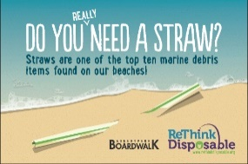
1.Refuse disposable plastic straws. If you really need a straw buy cardboard or other eco-options. Or invest in a metal or glass reusable straw.
2.Refuse single-use plastic bags.
1 million plastic bags are used globally every day,
and 500 billion are made each year.
If you really need a bag use paper.
Or invest in reusable plastic or (best of all) natural
fabric bags.

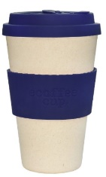
3.Refuse disposable drinks cups.
In the UK alone, we use seven million coffee cups
a day, that’s 2.5 billion a year. Less than 0.5% are
recycled properly. Take your own reusable cup –
many retailers now offer discounts too!

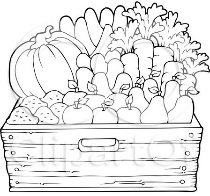
4.Avoid unnecessary food packaging. Buy loose produce. Take your own reusable bags. Remove packaging you’ll throw away at home and leave it at the store. Choose products packed in cardboard, glass or tin not plastic.
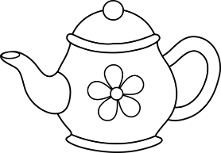
5.Make loose-leaf tea.
96% of teabags contain plastic.
Choose those which don’t or use a pot.
6.Don’t buy bottled drinks or meals in single-use
Plastic packs. Use a reusable water bottle and fill
with tap water, and take lunch from home in
non-plastic reusable tubs, or reuse margarine or
yogurt tubs you already have.
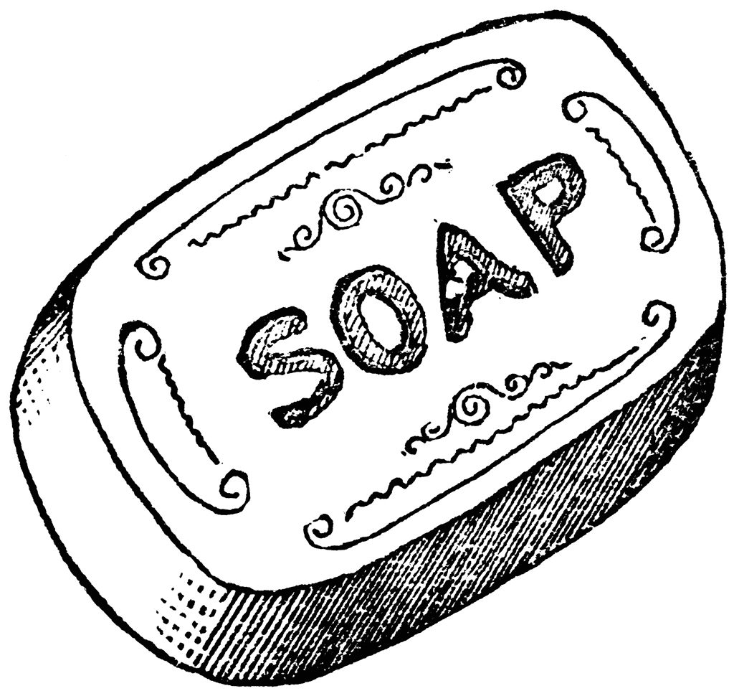
7.Use bars of soap instead of liquid soap in plastic
Bottles. Look for toiletries in non-plastic (or no) packaging.

Page 17
8.Don’t buy new CDs and DVDs.
Stream or download music shows and films or borrow them from the library or friends.

9.Avoid plastic pens.
Try using a fountain pen or pencils.
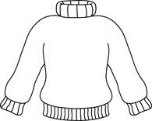
10.Choose natural fibres. Synthetic fabrics create
microfibre pollution when washed. Look for organic cotton, wool, and other natural fibres.

Page 18
My pledges for Lent:

You may like to pick one (or more) of these suggestions to practise in your own home this Lent, or you might have a better idea of your own!
Write down here what you will do.

Prayer

Holy God, thank you for the earth and the sea
that are full of your creatures;
living things both great and small.
Forgive us the damage we have done to your creation;
the earth lies polluted under our care.
Help us to change our ways of living
to be in tune with your creation
that, as we are revealed as your children,
all creation may be restored to glory.
Amen.
Page 19
The Lord God formed man from the dust of the ground, and breathed into his nostrils the breath of life; and the man became a living being. Genesis 2:7.

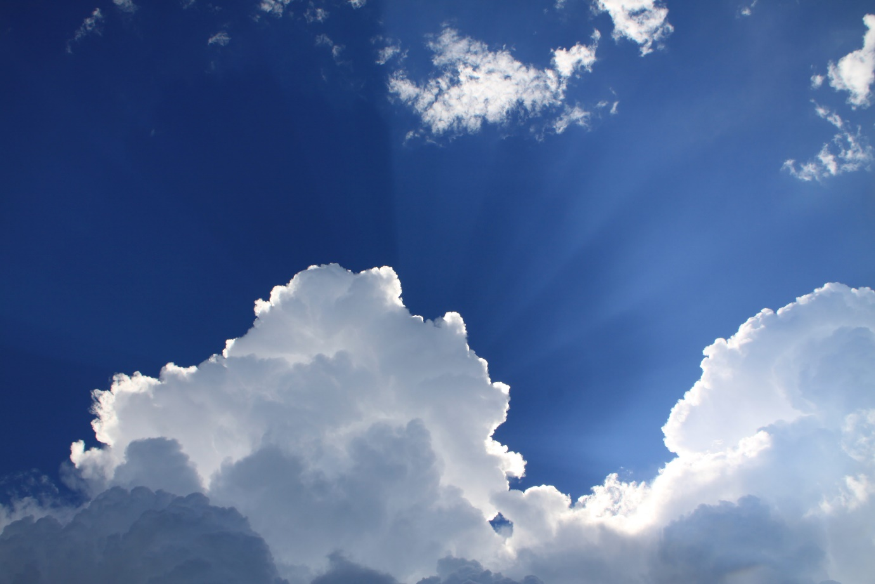

TRANSPORT
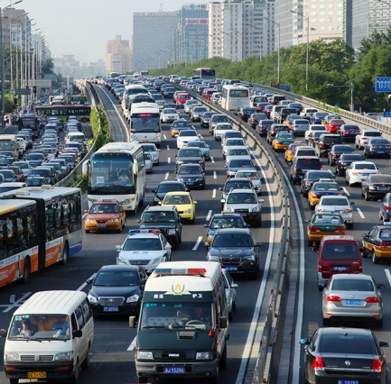
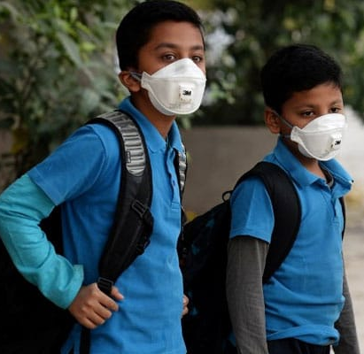

Everything on dry land in whose nostrils was the breath of life died. Genesis 7:22.

Page 20
Key Facts:

- Clean air is essential to life – literally God’s breath within us (Genesis 2).
- Air pollution is often unseen but increasingly recognised as a serious problem.
- Air pollution causes up to 36000 early deaths in the UK each year by worsening heart and breathing problems.
- It has also been shown to affect brain development in children and exacerbate teenage mental health conditions and forms of dementia.
- Over 2000 schools, nurseries and colleges are close to roads with illegal air pollution levels.
- Most air pollution comes from burning fossil fuels – in industry, the home and for transport. Whilst industrial and domestic pollution remain steady or are decreasing, traffic pollution is worsening across the world.
- Road traffic is the biggest contributor to air pollution, especially in built-up areas where toxic fumes are trapped by buildings.
- Vehicle fumes contain three major pollutants: Particulate matter (PM) which worsens heart and lung disease, Nitrogen Dioxide (NO2) which exacerbates asthma and breathing problems, and Ozone (O3) which irritates eyes, nose and mouth.
- Most areas of the UK breach EU legal limits for NO2. Forty UK towns and cities breach WHO legal limits for PM. London has some of the dirtiest air in Europe and has breached NO2 limits consistently for the last seven years.
- In 2017 the annual NO2 limit for Brixton Road was breached by January 5th! At one point, levels were nearly double the safe limit! In 2018 the annual limit was not breached until the end of January. Although still bad this shows improvement is possible.
- In addition to effects on human health, air pollution also causes acid rain, reduced crop yields and impaired forest growth and contributes to food poverty and global warming. Page 21
What can I do?

Make any changes possible to reduce your dependence on vehicle transport – for yourself, your food, your water, and all the goods you purchase.

10 easy actions for Lent (and the rest of your life).
1.Walk, run or cycle from A to B
It’s better for the earth, it’s better for your neighbours
and it’s better for you!
69% of car journeys are under 5 miles long.
23% of us use a car for trips of less than 1 mile
33% for trips of 1 – 2 miles and
79% for trips of 2 – 5 miles.
Most people can walk 3 miles or cycle 10 miles in one hour.

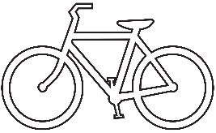
2.Avoid the busiest roads
and rush-hour times where possible to protect your own health.
The health benefits of exercise outweigh the risks of air pollution in every normal situation.
3.Take the bus.
One engine moves a whole bus full of people at once – a massive pollution win-win!

4.Take the train.
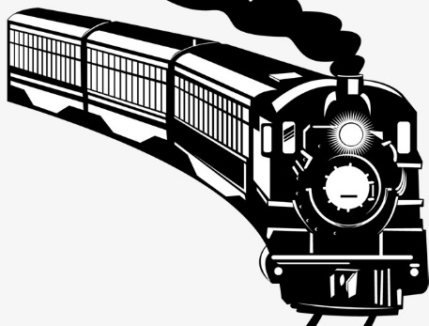
As above but with multiple carriages!

5 Buy local.
Watch your food miles – the less distance a
thing has travelled the better for the
earth and your health.
Use local suppliers and local traders.

Page 22
6.Plan your car journeys
so you do all your jobs in one trip.

7 Stop your engine in stationary traffic.

8 Buy wisely.
If you really need a car choose new cleaner
electric or hybrid models, or at least opt for
petrol over diesel – even the newest diesel cars
emit five times more NO2 than petrol versions.
9.Have a staycation!
Do you always need to fly (or drive)?
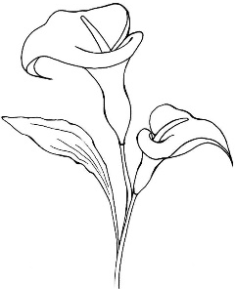
10 Grow houseplants.
Many varieties trap pollutants.
Try the Peace Lily or the prayer plant (Calathea).

Page 23
My pledges for Lent:

You may like to pick one (or more) of these suggestions to practise in your own life this Lent, or you might have a better idea of your own!
Write down here what you will do.

Prayer

Holy God, thank you for the air we breathe;
your breath giving us life.
Forgive us the damage we cause
through laziness, convenience;
the earth lies polluted under our care.
Help us to change our ways of living
to be in tune with your creation
that, as we are revealed as your children,
all creation may be restored to glory.
Amen.

Page 24

